Pixel to Byte Converter Functional Design Specifications
  - Design and Implementation of CSI Controller IP
  - Version 4.0.1

  - Block Owner
Hana Samy Ahmed
  - Authors
Hana Samy Ahmed

This Page is left Blank Intentionally

Table of Contents
1 Table of Contents 1
2 Revision History 2
3 Overview 3
4 Operation and Description 3
4.1 Digital Interface 3
4.1.1 Parameters Names 3
4.1.2 Ports Names 3
4.2 Functional Description 3
4.3 Block Diagram 3
4.4 Timing Diagram 3
4.5 Verification Requirements 3

Revision History
Version | Date | Author(s) | Revision Notes | Owner Approval
1 | 16-1-2026 | Hana Samy

Overview
This block serializes parallel pixel data into a sequential byte stream suitable for the MIPI D-PHY controller. It supports dynamic configuration to handle multiple MIPI CSI-2 data types (RGB, YUV, RAW) by adjusting the serialization ratio and flow control at runtime. It also decodes the flow markers to provide precise Packet Control Signals for the downstream Packetizer.

Operation and Description

Digital Interface

Parameters Names
Parameter Name | Default | Description
MAX_PIXEL_WIDTH | 24 | Maximum input width (e.g., RGB888 needs 24 bits).
OUTPUT_WIDTH | 8 | Output width to the D-PHY (Standard MIPI byte lane).

Ports Names
Port Name | Port Width | Port Type | Description
i_cfg_data_type | 6 | Input | MIPI Data Type (DT) code. Determines the byte count per pixel.
Clocks and Resets
i_byte_clk | 1 | Input | The high-speed MIPI Byte clock. All logic in this block runs on this clock.
i_rst_n | 1 | Input | Active-low asynchronous reset.
Native Input (From AXI Streaming-TX)
i_native_data | 24 | Input | Parallel pixel data (RGB).
i_native_valid | 1 | Input | Valid indicator for the input pixel.
o_native_ready | 1 | Output | Backpressure Signal. Goes LOW while the converter is busy serializing the current pixel .
i_native_sof | 1 | Input | Start of Frame marker (aligned with first pixel).
i_native_eol | 1 | Input | End of Line marker (aligned with last pixel).
Byte Output
o_byte_data | 8 | Output | Serialized 8-bit data stream.
o_byte_valid | 1 | Output | Valid indicator for the output byte.
i_byte_ready | 1 |  | Backpressure from D-PHY
o_byte_frame_start | 1 | Output | FS Trigger: High on the first byte of the First Line.
o_byte_frame_end | 1 | Output | FE Trigger: High on the last byte of the Last Line (requires logic/counter).
o_byte_line_start | 1 | Output | PH Trigger: High on the first byte of Every Line.
o_byte_packet_done | 1 | Output | PF Trigger: High on the last byte of Every Line.

Supported Data Types & Serialization Ratios
The block implements a Look-Up Table (LUT) based on i_cfg_data_type to determine how many bytes to send per pixel.
Format | Data Type | Input Group | Output Group | Packing Description
RAW8 | 0x2A | 1 Pixel | 1 Byte | P1[7:0] -> Byte0
YUV422 / RGB565 | 0x1E / 0x22 | 1 Pixel | 2 Bytes | P1[15:8] -> Byte0  P1[7:0] -> Byte1
RGB888 | 0x24 | 1 Pixel | 3 Bytes | P1[23:16] -> Byte0  P1[15:8] -> Byte1  P1[7:0] -> Byte2
RAW10 | 0x2B | 4 Pixels | 5 Bytes | Standard CSI-2 Packing:  Bytes 0-3: MSBs (Bits 9:2) of Pixels 1-4.  Byte 4: Aggregated LSBs (Bits 1:0) of Pixels 1-4.

Functional Description
1. Dynamic Serialization & Gearbox Packing
The core function is a configurable state machine that adapts its behavior based on the i_cfg_data_type. It operates in one of two modes:
- Mode A: Simple Serialization (Intra-Pixel):
Used for formats like RGB888 (1:3), RGB565 (1:2), and YUV422 (1:2).
  - Load Cycle: On valid input, the pixel is latched. Byte 0 is output immediately.
  - Busy Cycles: o_native_ready is pulled LOW. The remaining bytes (Byte 1, Byte 2, etc.) are shifted out sequentially.
  - Completion: Once the specific byte count for that format is reached, o_native_ready returns HIGH.
- Mode B: Gearbox Packing (Inter-Pixel):
Used for RAW10 (4 Pixels 5 Bytes). The block processes pixels in groups of four.
  - Accumulation (Cycles 1-4):
    - The block accepts 4 consecutive pixels.
    - For each pixel, the upper 8 bits (MSBs) are sent to o_byte_data immediately.
    - The lower 2 bits (LSBs) are stripped and stored in an internal "LSB Buffer".
  - Flush (Cycle 5):
    - After the 4th pixel, o_native_ready goes LOW (Busy) for exactly one cycle.
    - The block outputs the 5th byte, composed of the aggregated LSBs from the previous four pixels.
2. Variable Flow Control (Backpressure)
Since the serialization ratio changes based on the Data Type, the o_native_ready handshake pattern varies:
- 1:1 (RAW8): Ready stays HIGH (no backpressure).
- 1:N (RGB/YUV): Ready toggles (HIGH for 1 cycle, LOW for (N-1) cycles).
- 4:5 (RAW10): Ready stays HIGH for 4 cycles, then LOW for 1 cycle (during the LSB flush).
3. Marker Logic (Packetizer Triggers)
The converter decomposes pixel flags into byte-level triggers. The timing of these triggers is Data Type dependent.
- Start of Line (o_byte_line_start):
  - Asserts: HIGH during Byte 0 of the very first pixel of any line.
  - Usage: Triggers the Packetizer to generate the Long Packet Header (PH).
- Start of Frame (o_byte_frame_start):
  - Asserts: HIGH during Byte 0 of the first pixel, only if i_native_sof is present.
  - Usage: Triggers the Packetizer to send the Frame Start (FS) Short Packet.
- Packet Done / End of Line (o_byte_packet_done):
  - Asserts: HIGH during the Last Byte of the serialization sequence for the last pixel/group.
    - RGB888: Byte 2 of the last pixel.
    - RAW10: The 5th (LSB) byte of the last pixel group.
  - Usage: Triggers the Packetizer to calculate the Checksum and end the Long Packet.
- End of Frame (o_byte_frame_end):
  - Asserts: Coincident with o_byte_packet_done when the standard i_native_eol logic indicates the last line of the image.

Block Diagram
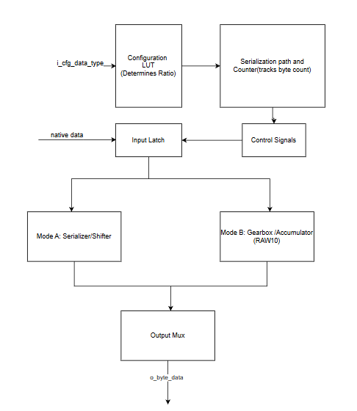

Timing Diagram
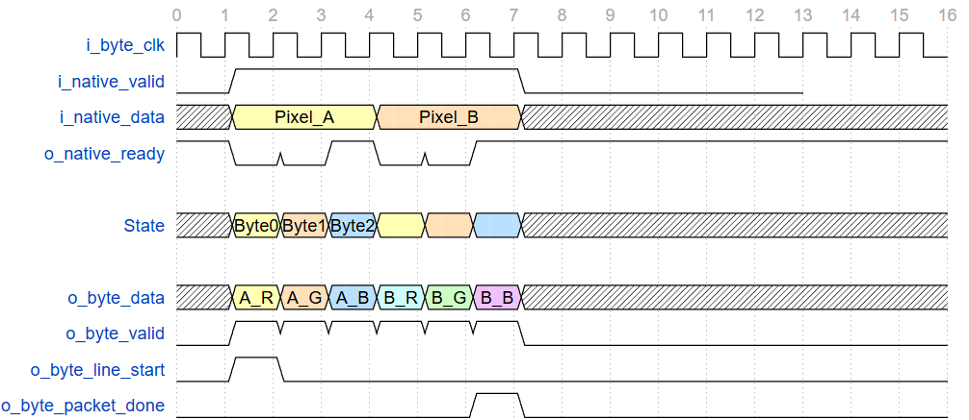

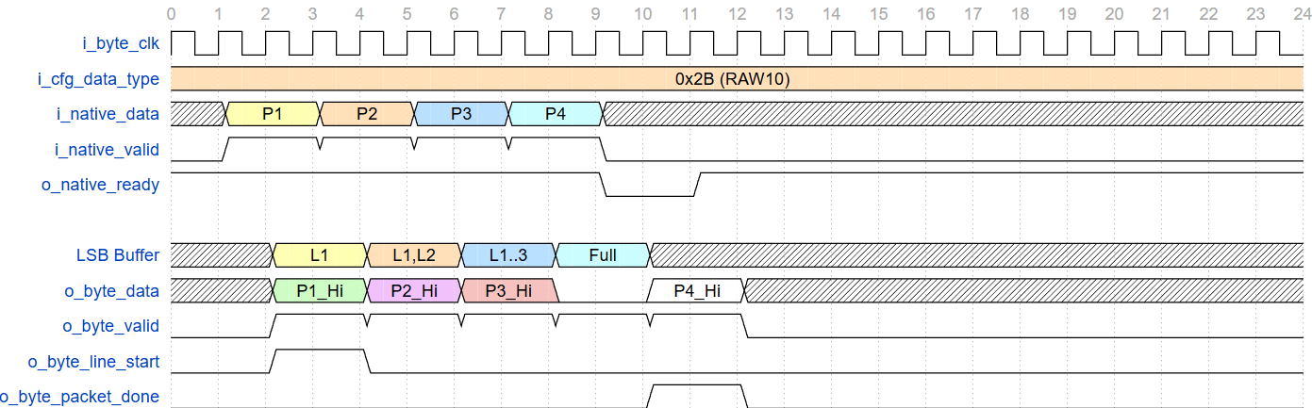

Verification Requirements
To ensure this block functions correctly, the following scenarios must be verified:
- Protocol Compliance: Verify that o_native_ready correctly asserts and deasserts based on the selected Data Type (e.g., toggles for RGB888, pauses every 5th cycle for RAW10) to prevent upstream data loss.
- Data Integrity: Verify that incoming pixel data is correctly serialized (or packed in RAW10 mode) into the output byte stream, ensuring bit-perfect reconstruction of the image data.
- Packet Flag Alignment: Verify that o_byte_line_start asserts on the exact first byte of the line and o_byte_packet_done asserts on the exact last byte of the line (delaying the input EOL signal as needed).
- Downstream Backpressure: Perform simulation where i_byte_ready is forced Low randomly during active serialization cycles to ensure the internal FSM pauses correctly without dropping or duplicating bytes.
- Corner Case Handling: Verify that in RAW10 mode, if a line ends with fewer than 4 pixels (Partial Group), the block immediately flushes the remaining LSBs and asserts o_byte_packet_done correctly.

